Sleep Tips For Teens – What you can do to Sleep Better

- Follow a schedule where you have regular bed and wake times, even on weekends, so you stay in sync with your sleep-wake cycle.
- Try to get at least 8.5 hours of sleep each night, preferably around 9.25 hours. Time I will go to bed on school nights _______________ pm.

- Create your bedroom environment so that it is comfortable, relaxing, quiet, cool and dark. Try keeping the lights dim at night to prepare you for sleep. In the morning, bright
light can help you become alert.

4. It’s best to not use televisions, computers or do homework in your bedroom close to bedtime. What’s in my bedroom that keeps me from sleeping?
TV Computer Homework Video games Music
Phone Lights Pets Other___________________________
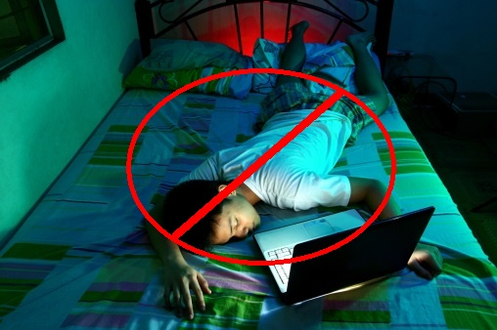
5. Set up a regular bedtime routine that helps you to fall asleep. This can include taking a
warm bath or shower, reading something you enjoy, listening to music that is not too
alerting or thinking pleasant thoughts. What I will do one hour before bed that is
relaxing _______________________________________________________________

6. Your mattress and pillow(s) should be comfortable.

7. Avoid caffeine (soda, energy drinks, coffee, tea, chocolate) close to bedtime. They can
keep you awake.

8. Avoid alcohol and nicotine.

9. Don’t go to bed too hungry or too full. Try light, nutritious snacks.

10. Exercise regularly to promote sleep, but complete your workout at least a few hours
before bedtime.
Adapted from www.sleepfoundation.org

